**Exercise: Business Location Analysis**

Please use the screenshots ONLY as a reference. The written instructions have to be followed AS written.

PLEASE MAKE SURE YOU SUBMIT ALL THE SCREENSHOTS WITH TIMESTAMPS AT THE BOTTOM RIGHT (WINDOWS USERS) OR THE TOP RIGHT (MAC OSX USERS) OR ELSE YOU WILL AUTOMATICALLY QUALIFY FOR A DISCOUNT.

### Objective:

*You have been appointed as a member of the strategy team of a high profile Asian food chain (Panda Hotpot) which is looking to open three locations in the Dallas-Fort Worth area. Your job is to carry out business location analysis keeping in mind that it is a mid-price (‘$$’ on Yelp!) hotpot chain with high-tech trendy architecture as standard across all countries.*

Using data available from Business Analysis ArcGIS Maps determine the three locations following the instructions provided below. We will further identify the geocodes of the shortlisted locations using ArcGIS Pro.

**Part 1: Sign up for Business Analyst by ArcGIS**

Step 1- Go to the website: [https://learn.arcgis.com/en/become-a-member/.](https://learn.arcgis.com/en/become-a-member/) Fill out the necessary details to get your account started up. Make sure you input correct information and use your UTD email address.

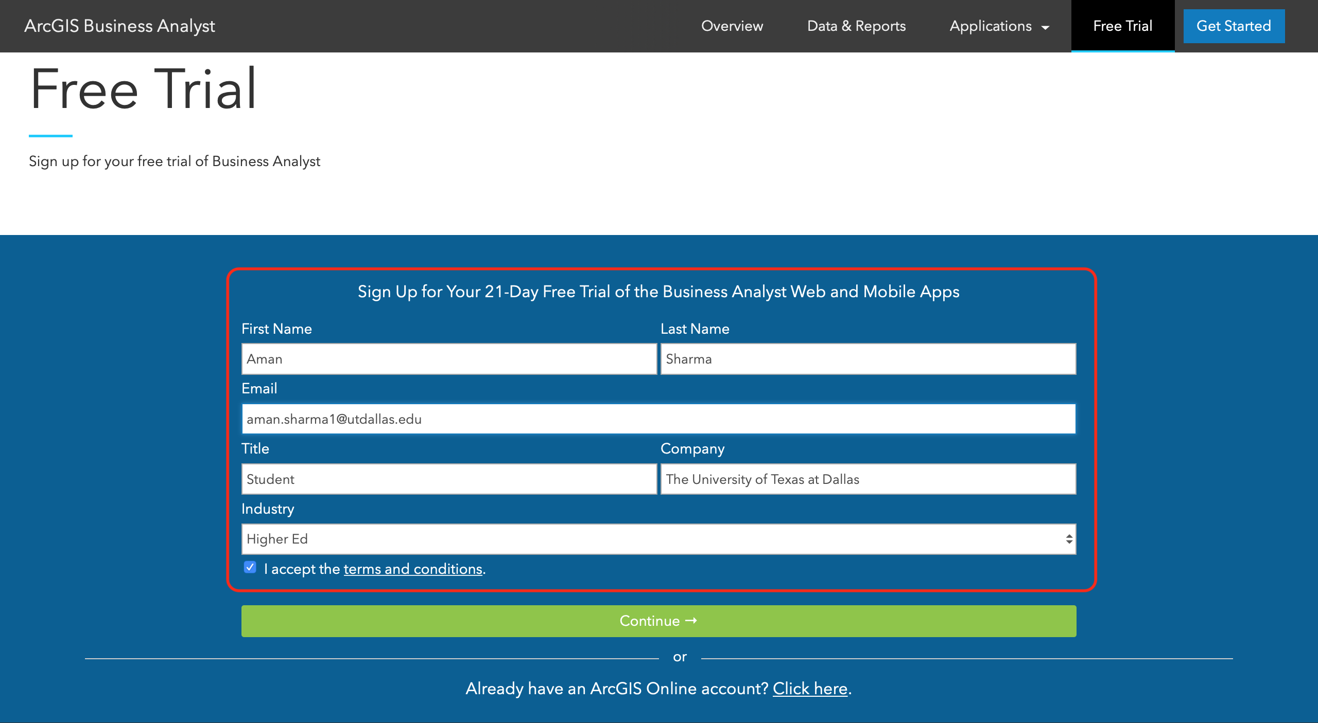

**Note: The interface might look a little different because it has been changed due to COVID 19.**

Step 2: In the next prompt make sure you select ‘Other’ and input ‘Education Purposes’ in the text prompt.

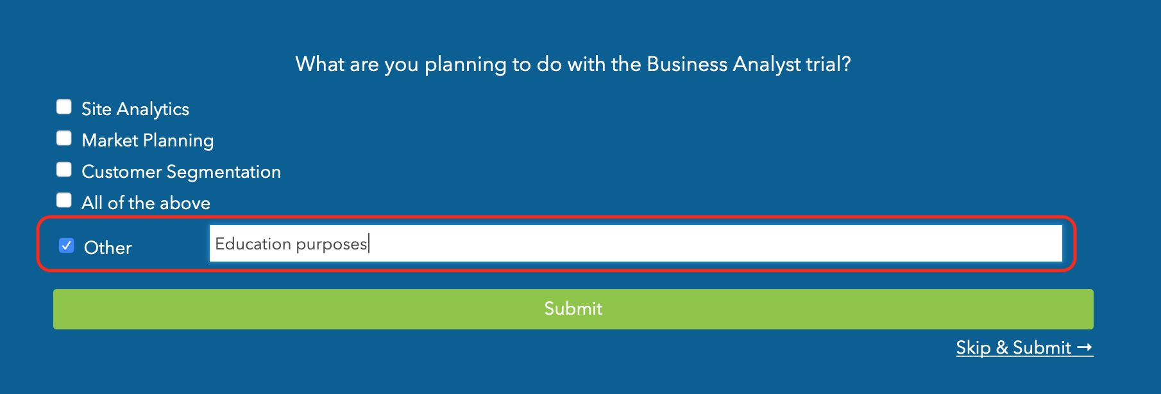

Step 3: You will receive an activation email for a 21-day free trail, please make sure you use the trial wisely. Go ahead and confirm your email address. You’ll be asked to input a username and password post activation. Also, make sure you save that email from Arc GIS because you will be needing that to download Arc GIS Pro in the further steps.

Q1. Paste a screenshot of the Homepage screen post Log in

Screenshot:

**Part 2: Setting up the project**

Step 1: Now that you are logged in, navigate to the ‘Maps’ tab and select ‘Create Project’.(If you cannot find it, use the below link and log in to your account to use a Business Analyst Trial).

<https://bao.arcgis.com/esriBAO/login/index.html>

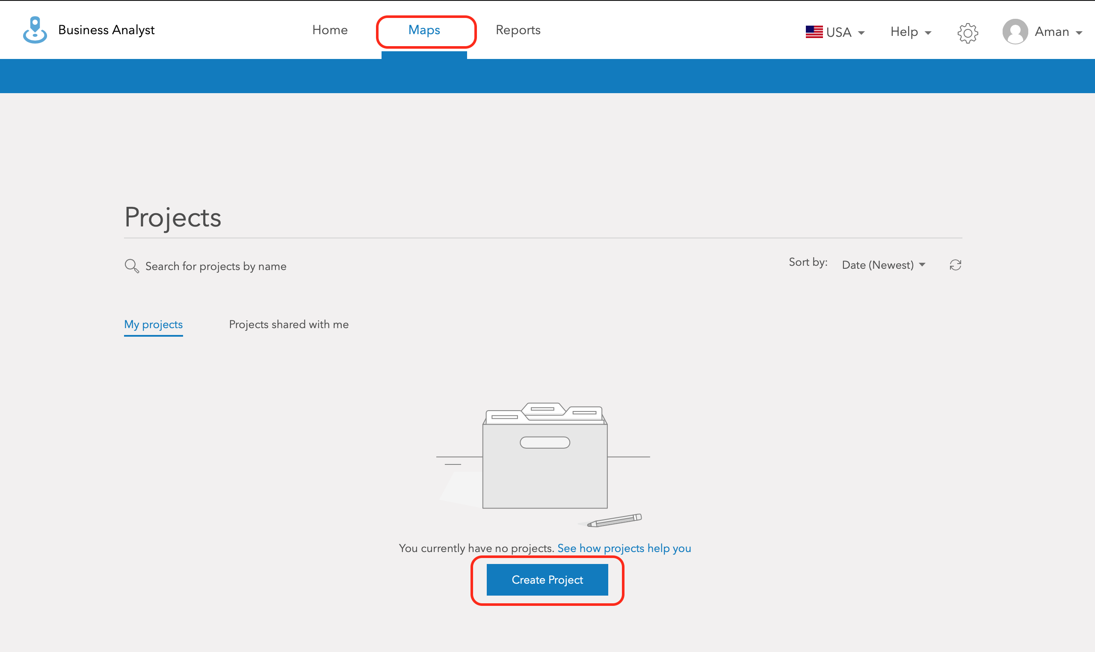

Step 2: Input the name of the project. Please note that project names have to be unique so make sure you follow the correct naming convention

‘Panda Hotpot – Student Name’

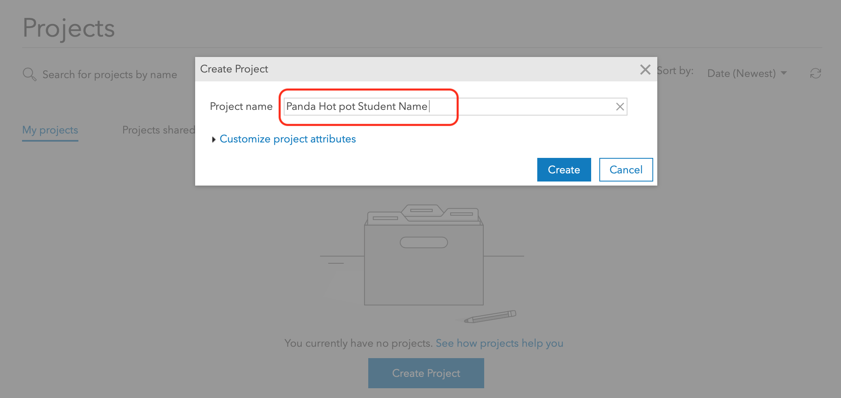

Q2. Paste a screenshot of the success message

Screenshot:

**Part 3: Creating Maps from Data**

Step 1: Close all the prompts that show up and make sure your screen coverage of the DFW map is almost similar to the one shown in the sample map below. Advice: Make sure you Graham is visible on the West side and Sulphur springs is visible on the East side of the map.

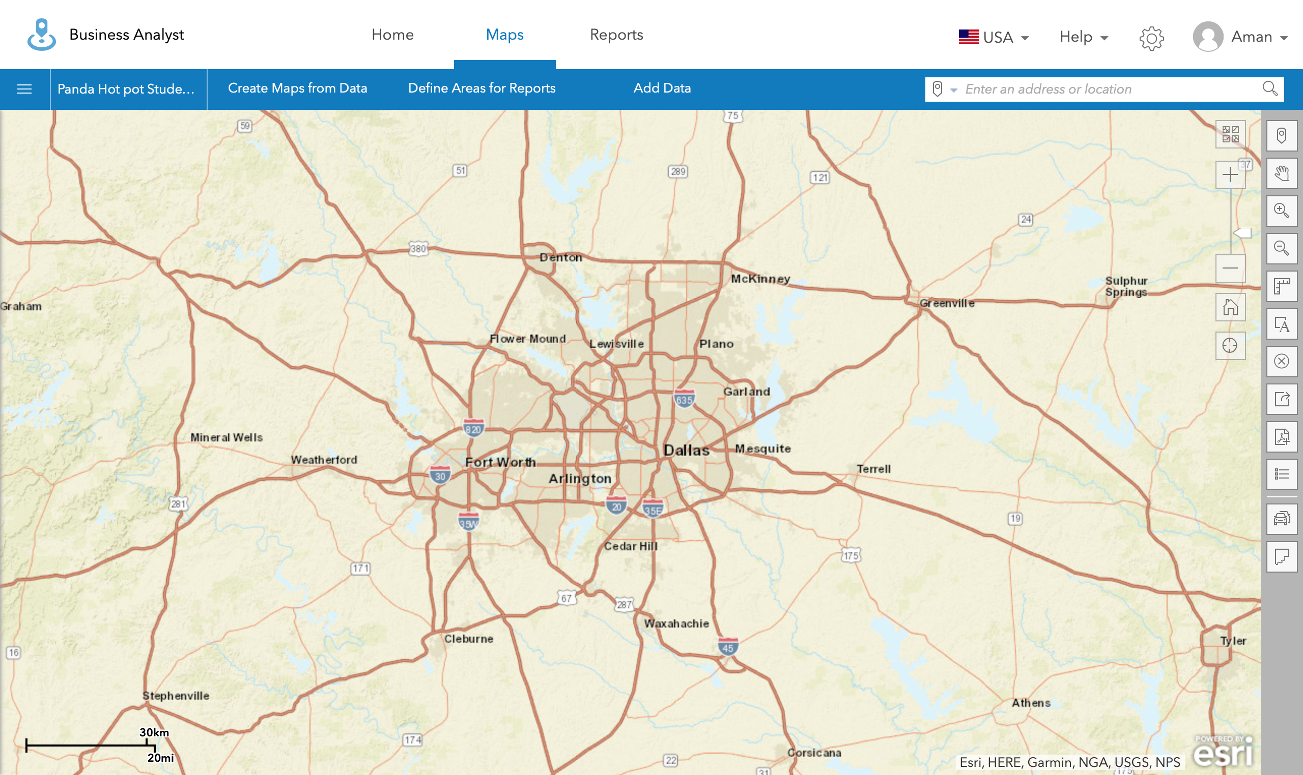

Step 2: Select ‘Create Maps from Data’ and then go ahead and select ‘Smart Map Search’

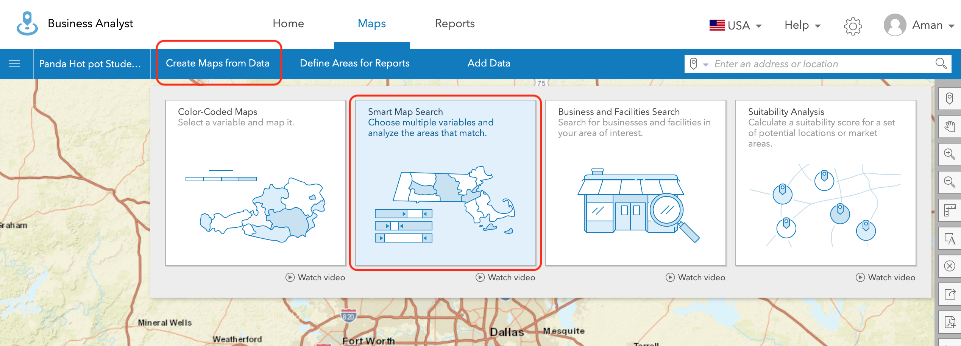

Step 3: You will see a sidebar, select ‘Get Started’. ‘Smart Map Search’ allows you to select up to 5 variables to perform your analysis. In our case, our job is to narrow down a few areas that make our selection of our restaurant chain locations suitable.

Step 4: Let us go ahead and select the most appropriate first variable – ‘Population’. We have to make sure that our shortlist of areas have a certain minimum number of residents.

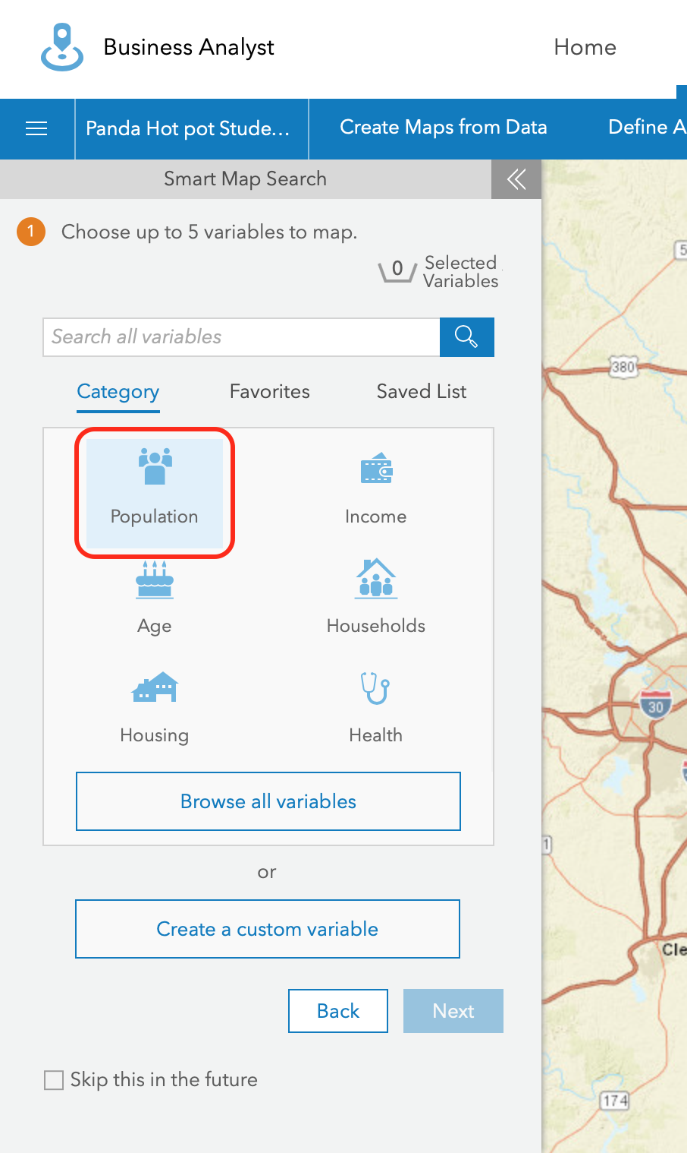

Select ‘(Current Year, ex. 2030) Total Population (ESRI)’ as shown in the screenshot. This is the most up to date census estimate determined by ESRI. Go ahead and apply this.

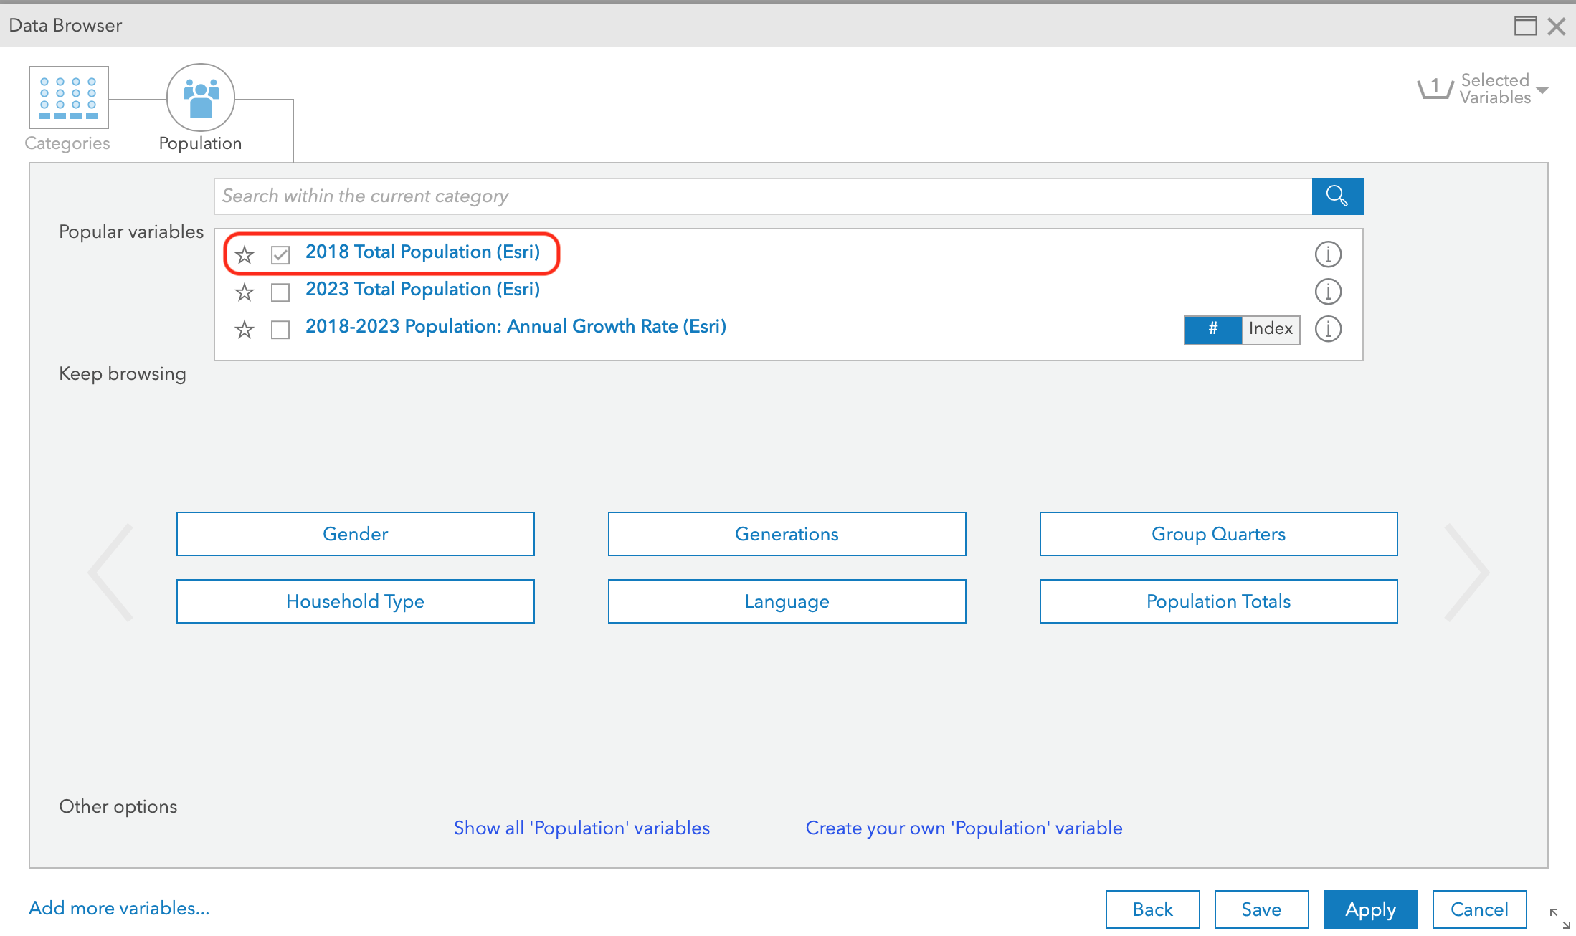

Step 5: It may take time but now your map is going to start gathering data. We have to adjust the sliders so let’s go ahead and select the minimum population as ‘25000’ as shown in the screenshot. Also, MAKE SURE THAT THE GEOGRAPHY LEVEL IS SELECTED AS ZIP CODES or else there will be a discount. Remember that you can minimize the sidebar using the button on the top right.

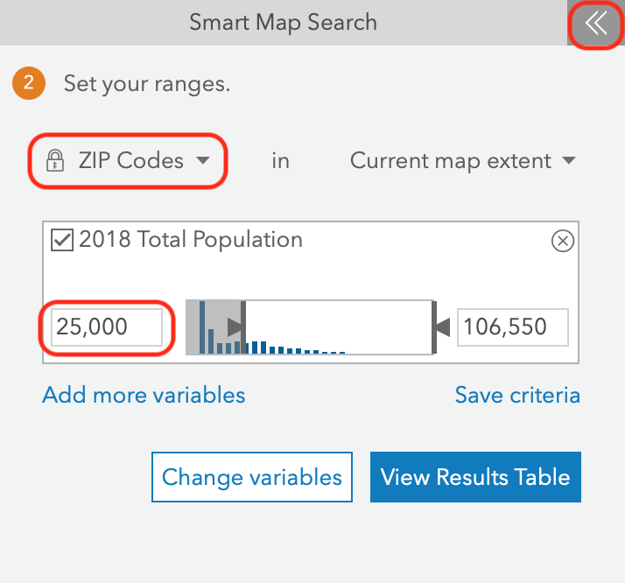

Q3. Paste a screenshot of your map highlighting the selected Zip Codes after minimizing the sidebar, make sure to always minimize your sidebar when asked for screenshots of the map

Screenshot:

Step 6: Select ‘Add more variables’

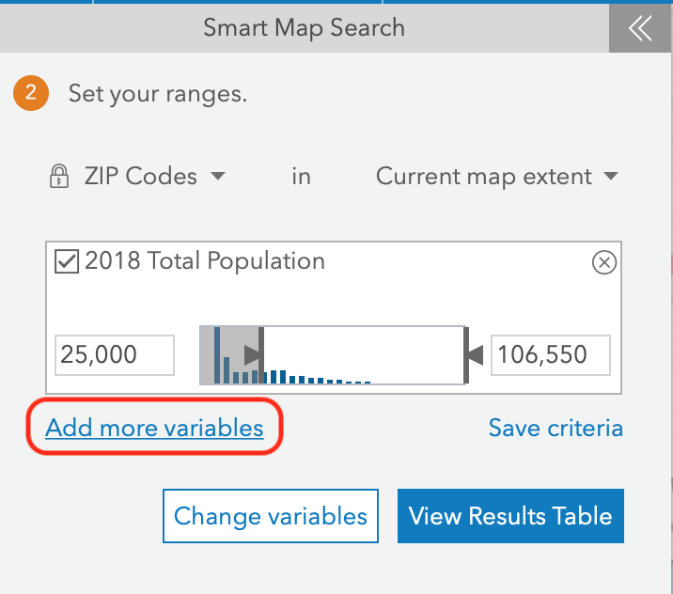

Step 7: Click on ‘Categories’ on the top left to get out of the population data area. Select ‘Race’ and select ‘Create a custom variable’ at the bottom.

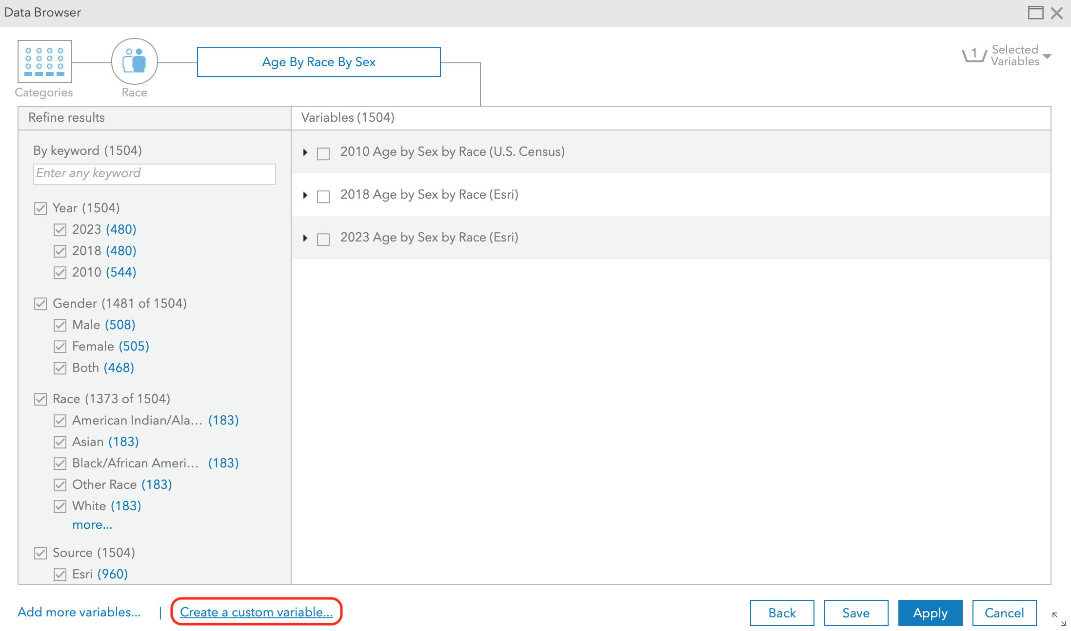

Step 8: Go ahead and navigate to ‘Race’ and select ‘Age By Race By Sex’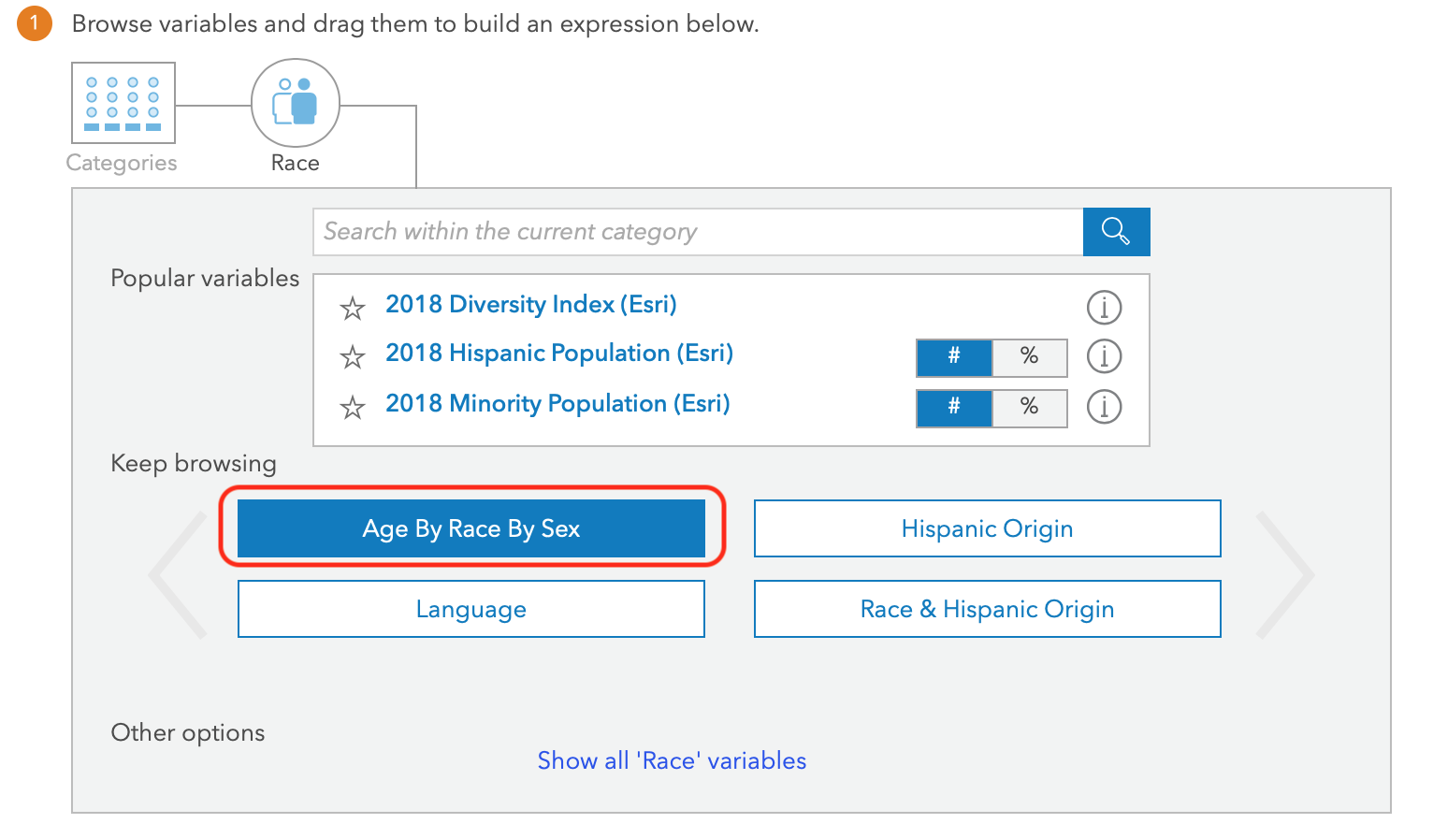

Step 9: Expand ‘(Current Year, ex. 2030) Age by Sex by Age (ESRI)’ and scroll down to ‘(Current Year, ex. 2030) Asian Population Age 0-4’ category.

Step 10: Our next variable would be ‘Asian Population’ as this demographic is another one which is most likely to eat at our restaurant. We have to drag and drop all the variables from the list to the calculation box at the bottom, make sure you drag and drop all the categories from the age groups of 15-54 as shown in the screenshot below. Also, make sure to include a ‘+’ after every category.

Note: The screen shot image below is a visual example, it is not reflective of the exact specification of 15-54 as required above. Please select only the age categories appropriate for the 15-54 specification.

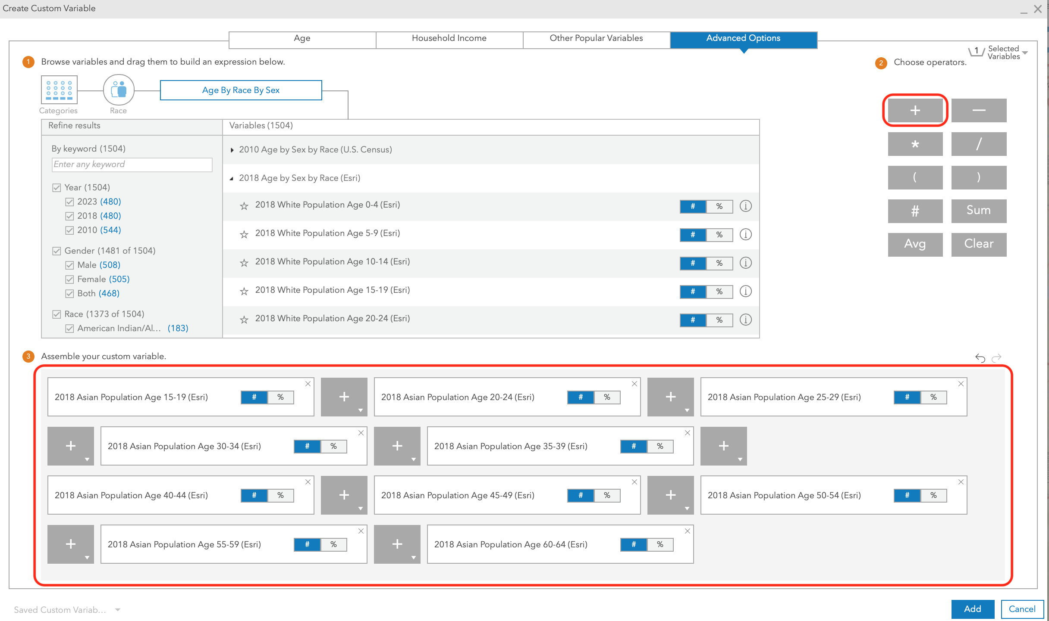

Step 11: Click on ‘Add’ and name the custom variable ‘Asian Population’.

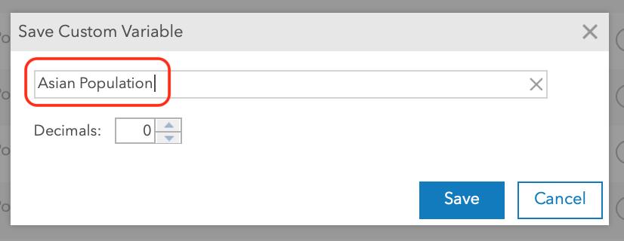

Step 12: Click on ‘Apply’ and adjust the sliders to:

Population: 25,000 (Minimum)

Asian Population: 2,000 (Minimum)

**PLEASE NOTE: YOU WILL HAVE TO REPEATEDLY ADJUST THESE SLIDERS AFTER ADDING NEW VARIABLES**

Q4. Paste a screenshot of your map zooming in appropriately to show all highlighted ZIP codes.

Screenshot:

Step 13: By now, you should be familiar to adding new variables. We are now going to test you on adding certain variables. Go ahead and add ‘(Current Year, ex. 2030) Median Household Income (ESRI)’ from the income category. Adjust the sliders for ‘Population’ and ‘Asian Population’ to the minimums as specified in the previous step.

Now, let’s focus on the Median Household Income. It is common knowledge that eating out can be expensive and as we brand our restaurant as a ‘Mid Price Restaurant Chain’, we should target zip codes where the median household income is in our selected range. Let’s set this to a minimum ‘$60,000’

Q5. Paste a screenshot showing your sliders to the required minimums

Screenshot:

Q6. Paste a screenshot of your map after setting minimum median household income

Screenshot:

Step 14: Another very important variable that we will now add is the Market Potential of Restaurants for the Zip Codes.

Market Potential: It is the amount expected to be spent by consumers in the retail market. This has a direct correlation with our business model.

So let’s go ahead and add this variable called:

2022 Restaurants (Market Potential)

It can be found under ‘2022 Bought Panda Express Last 6 months’

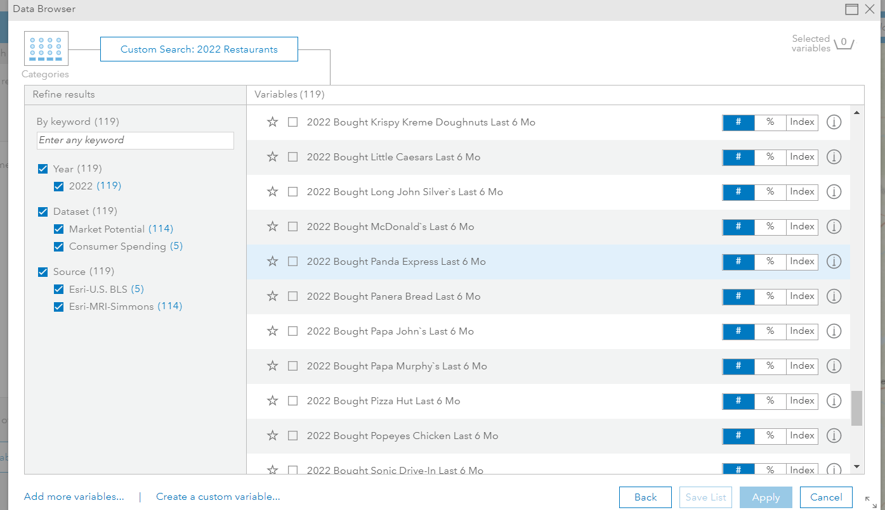

Set the minimum value of this to be 900 to 11457.

Q7. Paste a screenshot of your sliders after setting up the minimums

Screenshot:

Q8. Paste a screenshot of your map area after minimizing the sidebar

Screenshot:

Step 15: The last variable that we are going to add to our filtering is going to be a calculated ‘Tapestry’ variable.

Tapestry gives us insights to help us identify our best customers, optimal sites, and underserved markets. As a result, we will get higher response rates, avoid less profitable areas, and invest our resources more wisely.

Go ahead and create a custom variable from the ‘Tapestry’ Category. Select ‘Tapestry Adults’. There are certain profiles of target customers given below and you have to go through these 69 tapestry variables to select the most suitable 5 and add them.

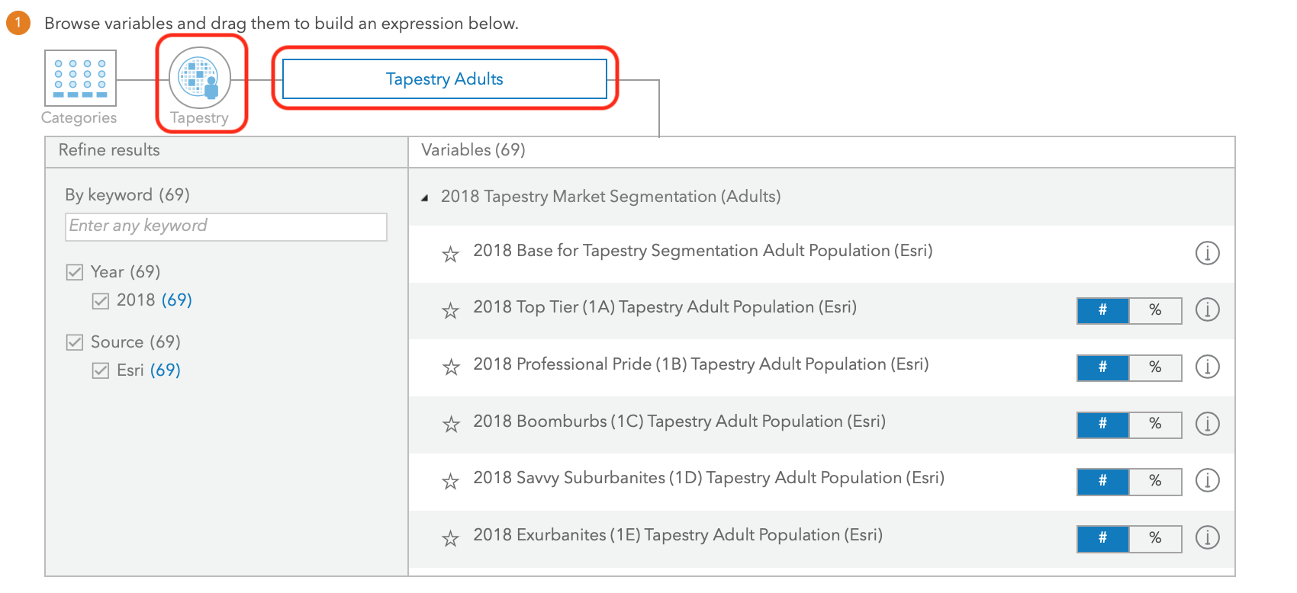

You will now be tested on your identification of the most appropriate tapestry variable of the customer profiles highlighted below:

CUSTOMER PROFILE 1: *This is the new growth market, with a profile similar to the original: young professionals with families that have opted to trade up to the newest housing in the suburbs. This is an affluent market but with a higher proportion of mortgages. Residents are well-educated professionals with a running start on prosperity.*

CUSTOMER PROFILE 2: *Residents are predominantly single, well-educated professionals in business, finance, legal, computer, and entertainment occupations. They are affluent and partial to city living—and its amenities. Neighborhoods are densely populated, primarily located in the cities of large metropolitan areas. Although single householders technically outnumber couples, this market includes a higher proportion of partner households, including the highest proportion of same-sex couples. Residents are more interested in the stock market than the housing market. They are active and health conscious, and care about the environment.*

CUSTOMER PROFILE 3: *Armed with the motto “you’re only young once,” these residents live life to its full potential. These educated young singles aren’t ready to settle down; they tend to not own homes or vehicles and choose to spend their disposable income on upscale city living and entertainment. Dressed head to toe in the most current fashions, their weeknights and weekends are filled discovering local art and culture, dining out, or exploring new hobbies. Their vacations are often spontaneous, packed with new experiences and chronicled on their Facebook pages.*

CUSTOMER PROFILE 4: *Residents are younger and more mobile and ethnically diverse than the previous generation. They are ambitious, working hard to get ahead, and willing to take some risks to achieve their goals. The recession has impacted their financial well-being, but they are optimistic. Their homes are new; their families are young. And this is one of the fastest-growing markets in the country.*

CUSTOMER PROFILE 5: *Gen Y comes of age: Well-educated young workers, some of whom are still completing their education, are employed in professional/technical occupations, as well as sales and office/administrative support roles. These residents are not established yet, but striving to get ahead and improve themselves. This market ranks in the top 5 for renters, movers, college enrollment, and labor force participation rate. Almost 1 in 5 residents move each year. More than half of all householders are under the age of 35, the majority living alone or in shared nonfamily dwellings. Median household income is still below the US Smartphones are a way of life, and they use the Internet extensively. Consumers are diverse, favoring densely populated neighborhoods in large metropolitan areas; over 50% are located in the South (almost a fifth in Texas), with the rest chiefly in the West.*

Q9: List the exact Tapestry you selected for the following:

Customer Profile 1:

Customer Profile 2:

Customer Profile 3:

Customer Profile 4:

Customer Profile 5:

Step 16: Go ahead and create this variable after adding your selection of variables as ‘Tapestry Variable’ and the set minimum limit to ‘20,000’.

Q10. Paste a screenshot of the sidebar along with the variables with minimums as determined from previous steps

Screenshot:

Q11. Paste a screenshot after clicking ‘View Results Table’ showing the shortlisted zip codes

Screenshot:

Q12. Paste a screenshot of your map area after minimizing the sidebar

Screenshot:

**Part 4: Updating Drive Time**

You may see neighboring Zip codes as the concentration of our desired customer demographic may be residing closer in proximity. To overcome this problem you will need to follow these steps.

Step 1: In case you have shortlisted neighboring zip codes, please select ‘Pin’ from the right sidebar and place it in a location you feel is ideal for the people from both(or more) zip codes to drive to. Let us create drive rings in our map.

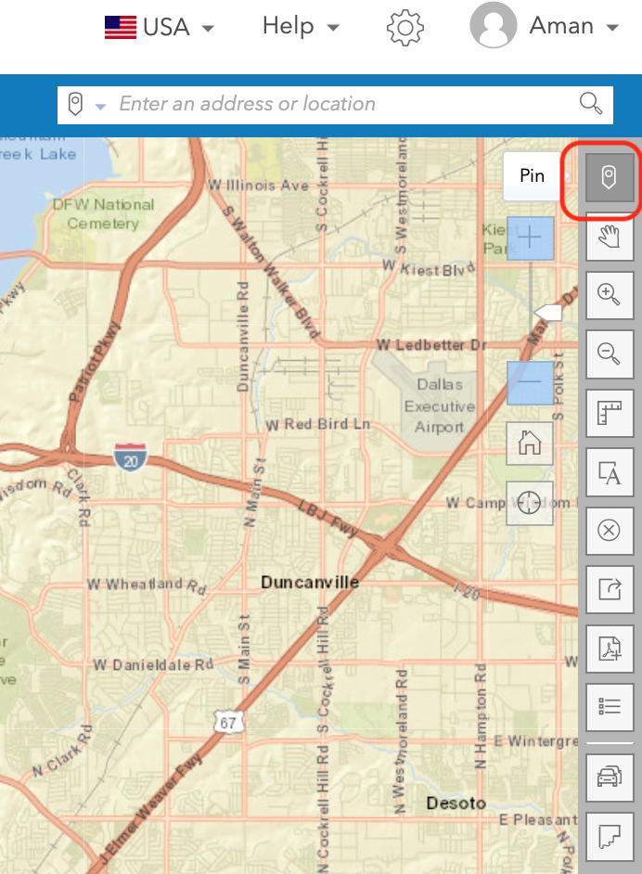

Step 2: Once you place your first pin, rename the site name to ‘Location 1’. Then go ahead and select ‘Add Rings’

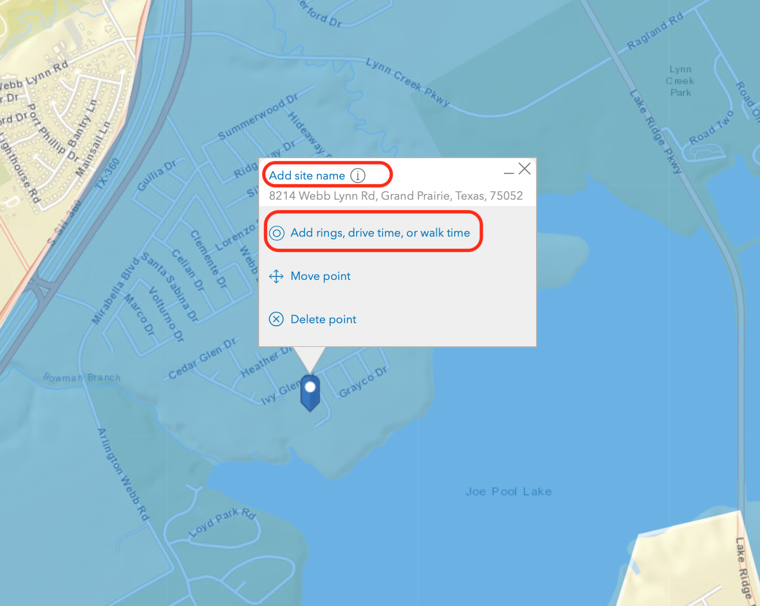

Step 3: Navigate to the ‘Drive Times’ tab and select 5,10,15 minutes as your ring intervals and you will see something like the following image. Notice the underlying shortlisted Zip Codes (Light blue layer) and on top of that we have 3 colored rings (Red, Green and Dark Blue) for our selected driving intervals. Establishing one single restaurant in convenience of the residents of two shortlisted zip codes is more feasible than setting up a restaurant in each.

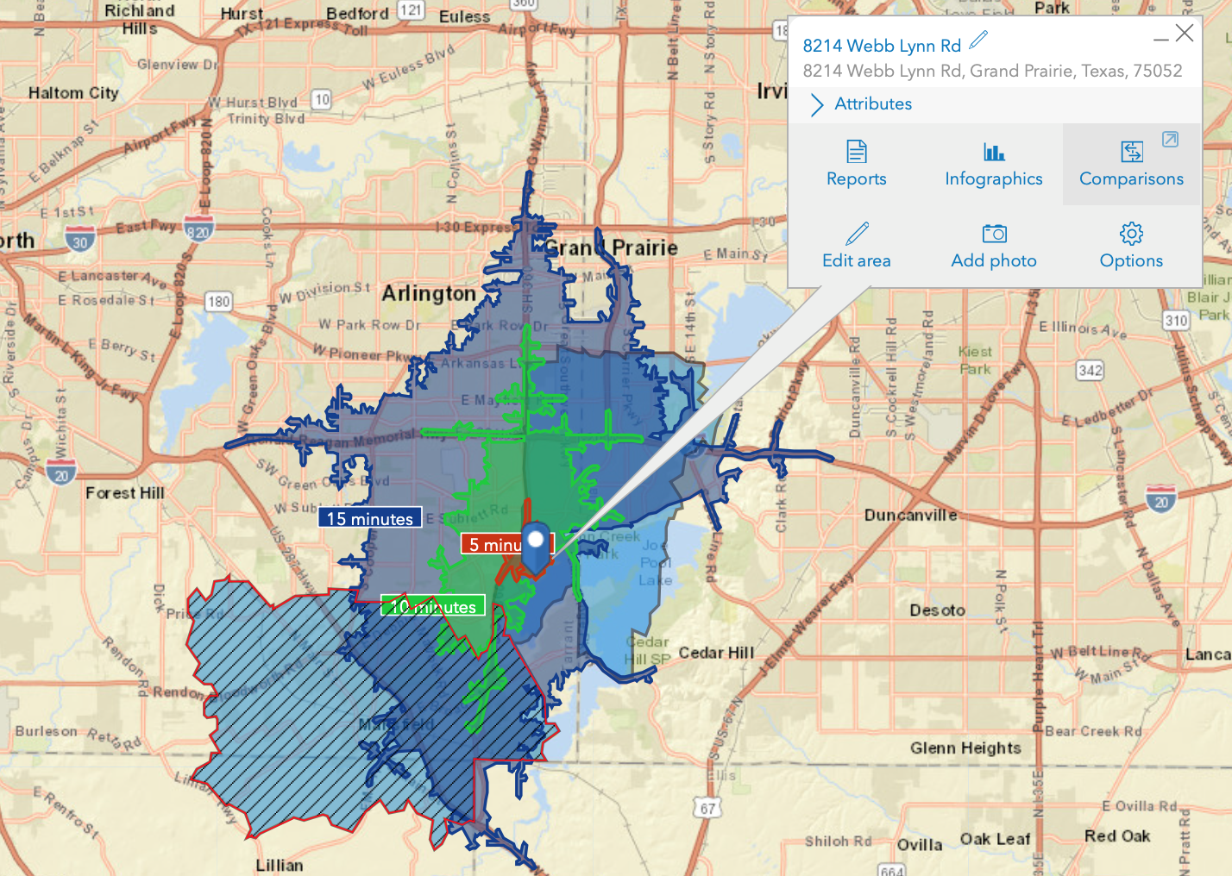

Step 4: Repeat this step if you end up encountering more than one area where two shortlisted zip codes are neighboring.

Step 5: Your main aim is to establish 3 restaurant chains at first so with reasons, select 3 locations in your shortlist zip codes. By now, you should be familiar with the functionality of BOA ArcGIS so go ahead, drop the 3 pins at your ideal locations across your shortlisted zip codes.

Step 6: After doing that, rename your next locations as ‘Location 2’ and ‘Location 3’ along with displaying the driving rings in 5,10 & 15 minute intervals.

Q13. Paste a screenshot of the three shortlisted locations on map along with driving rings after minimizing the sidebar.

Screenshot:

**Part 5: Geocoding coordinates**

Step 1: Now that we have our 3 potential locations, let us convert the address to map friendly geocodes. This will be done by getting the addresses of all 3 locations into a CSV file. Suppose the dummy location provided in the screenshot below is one of our potential locations, map the address in an excel worksheet in the same manner.

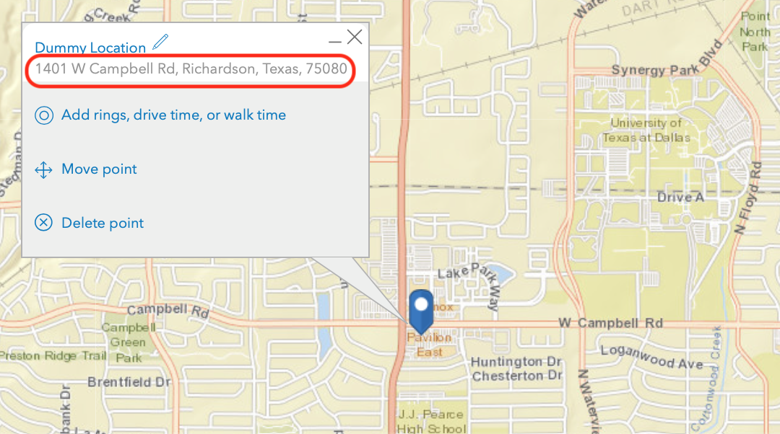

Your new excel workbook should look like below for the above address:

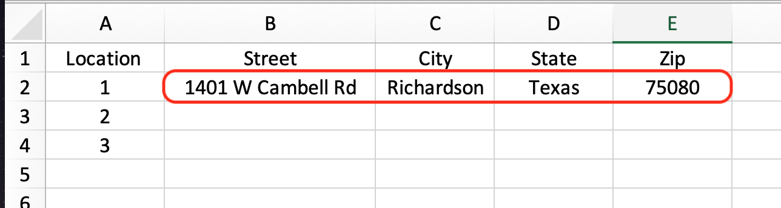

Go ahead and input the address of three locations of your choice in the excel sheet and then save the file as CSV.

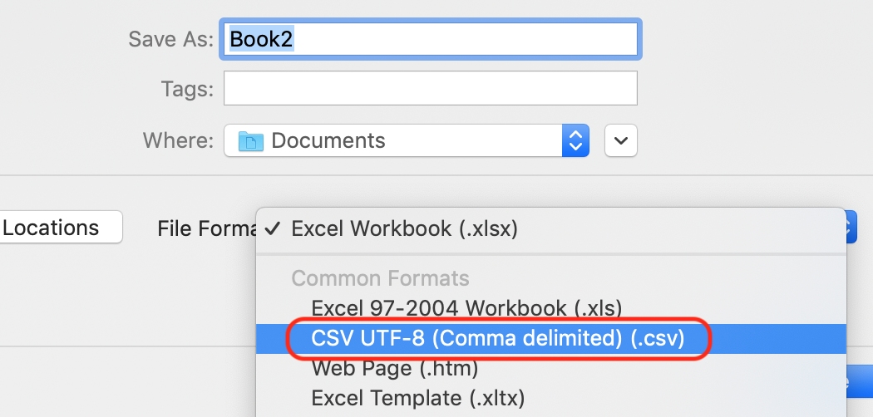

Q14. Paste a screenshot of your excel workbook showing the addresses of the three locations.

Screenshot:

Step 5: Now that you have a CSV file of your locations we need to upload them in the ArcGIS mapping program. Use the link below to download ArcGIS Pro.After a successful download, install the program.

<https://utdallas.box.com/v/ARCGISPROVIS>

Step 6: Upon successful installation of ArcGIS Pro, go ahead and launch it. You may be prompted to login using your credentials. Create a new project using your name and you will see a new project open up. In the ‘Insert’ tab, on the top left of the window, select ‘New Map’.

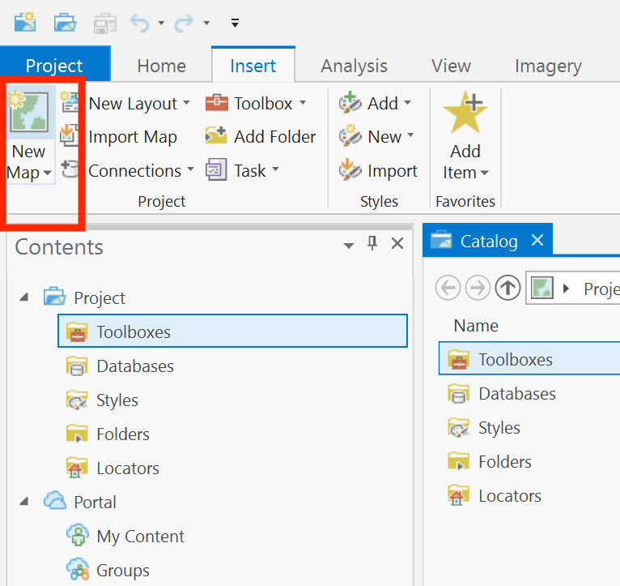

Now, select ‘Add Data’. Import your location CSV file.

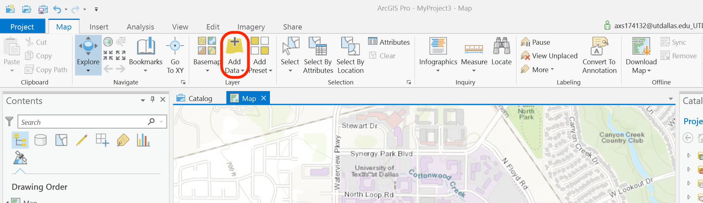

Upon a successful import, it will be visible under the contents section on the left.

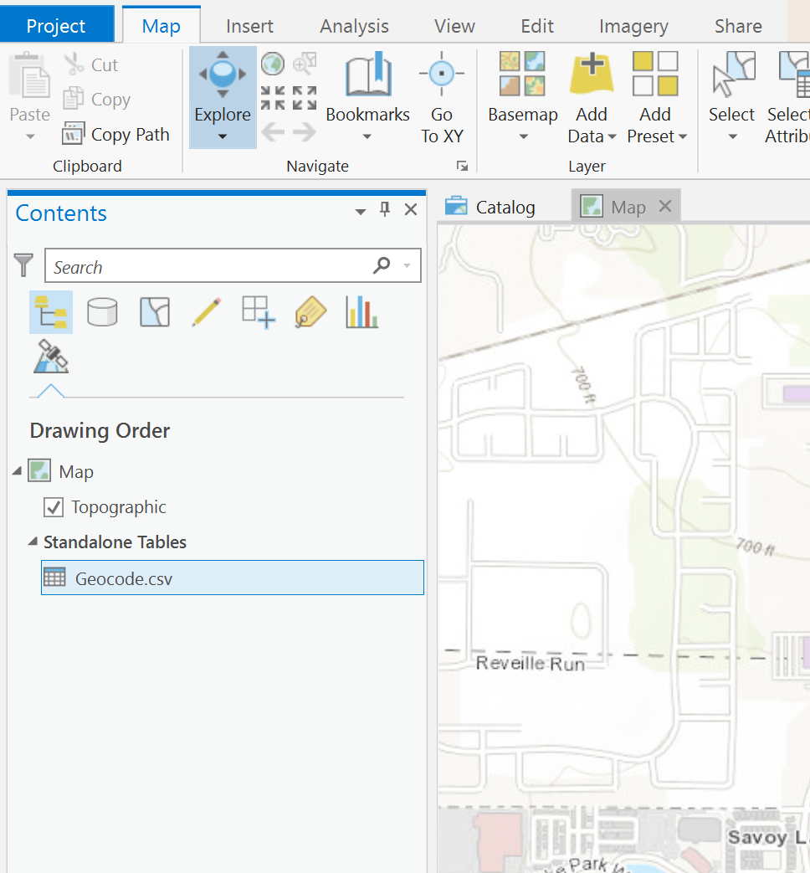

Step 7: Right click the ‘.CSV’ extension file and select ‘Geocode Table’. A new pane will open up on the right. Upon prompt of Input Locator, select ArcGIS World Geocoding Service. Click Next.

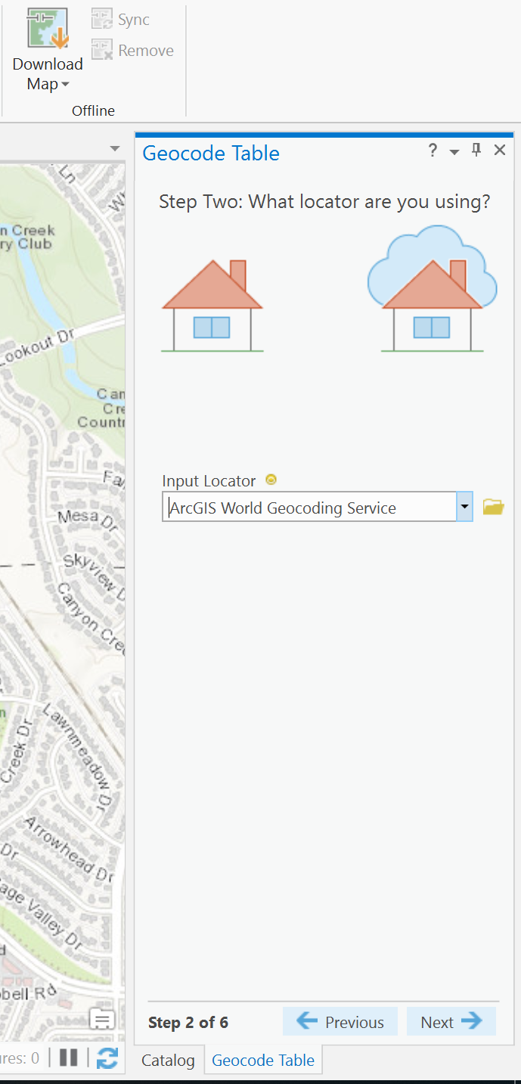

Select the appropriate columns from your CSV file into the corresponding columns.

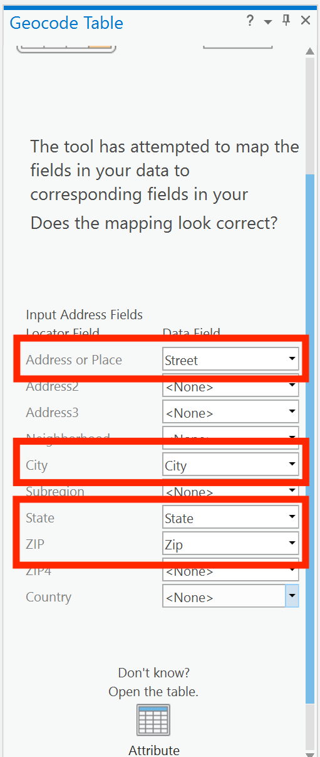

On the next prompt, select United States as the country.

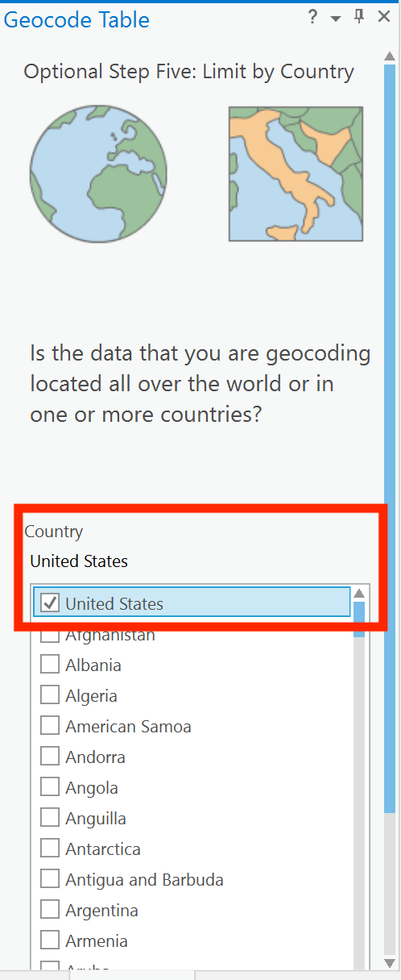

Cross check all the fields in the next prompt and click Run.

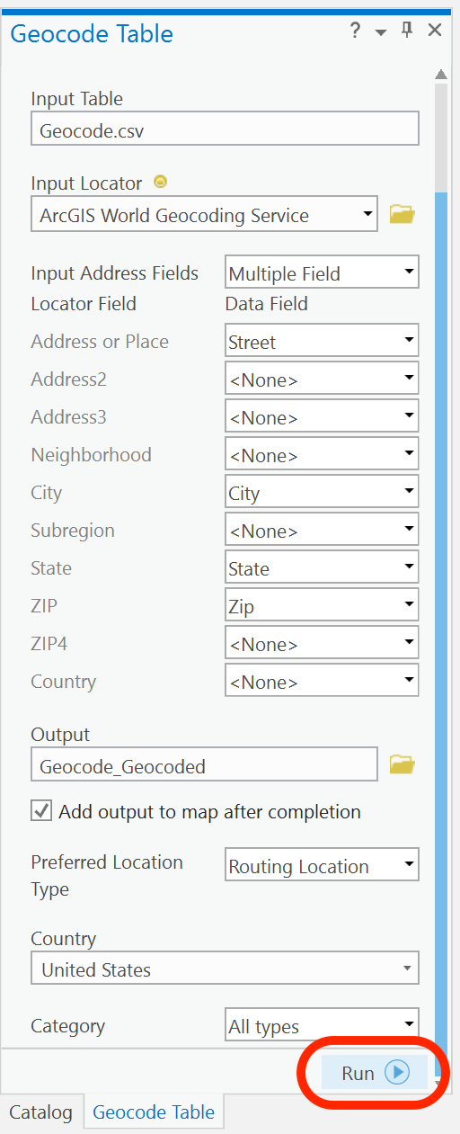

After a successful geocoding process, you will be asked to ‘Start the Rematch Process’. Select NO.

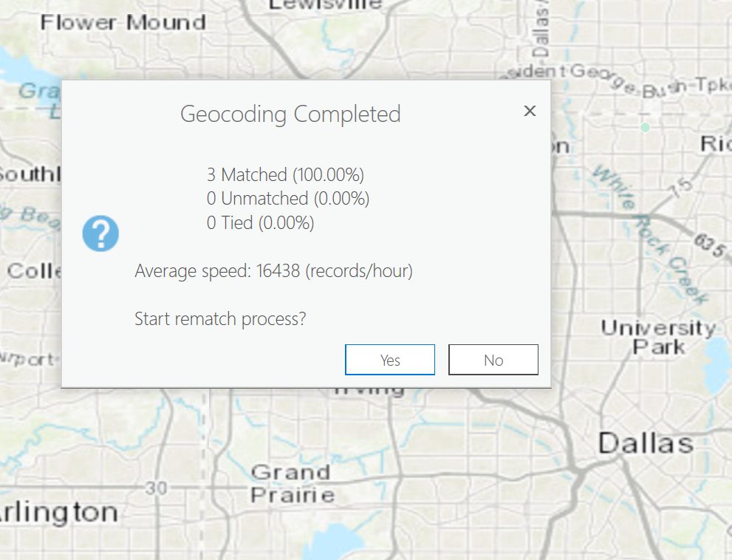

Step 8: Under the contents section on the left, you will see your geocoded output table. Right Click it and select ‘Attribute Table’.

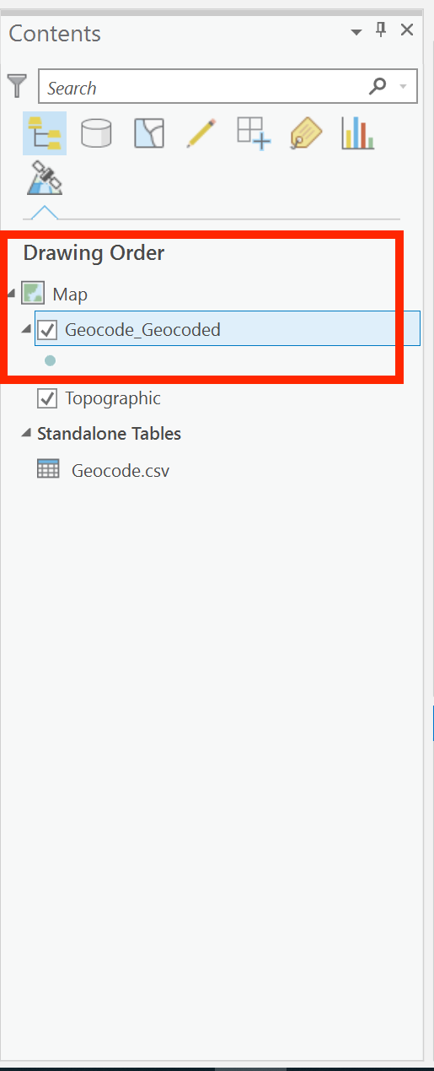

You will now see a table below the map containing your locations, scroll to the right until you see the ‘X’ and ‘Y’ columns (sample shown in screenshots below). These are the Geocoordinates of your shortlisted locations.

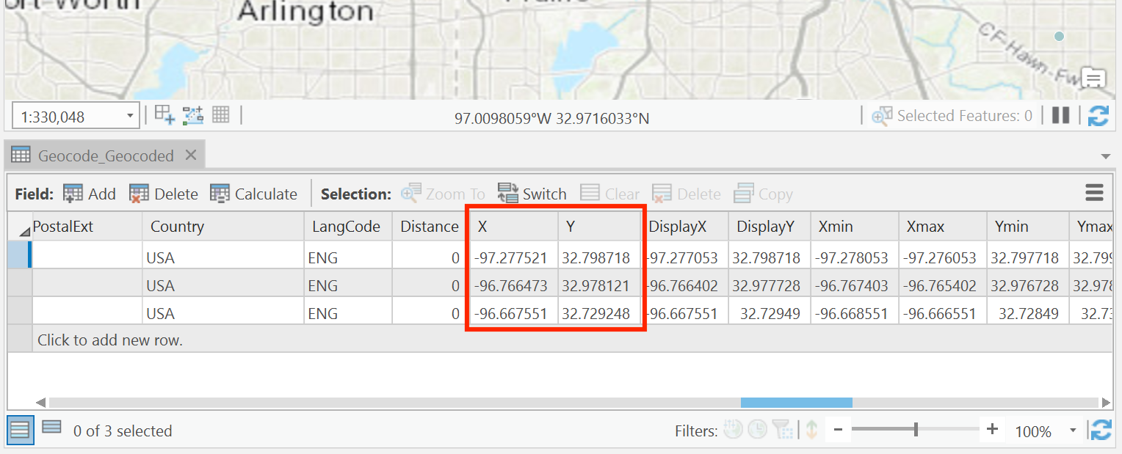

Q15. List the geocoordinates of the three locations

Answer: Location 1 :

X - Y -

Location 2 :

X - Y -

Location 3 :

X - Y -

Q16. Place a screenshot of the complete window showing your credentials on the top right and the points plotted on the map in ArcGIS Pro

Screenshot:

PLEASE MAKE SURE YOU SUBMIT ALL THE SCREENSHOTS WITH TIMESTAMPS AT THE BOTTOM RIGHT (WINDOWS USERS) OR THE TOP RIGHT (MAC OSX USERS) OR ELSE YOU WILL AUTOMATICALLY QUALIFY FOR A DISCOUNT.

Make sure you submit the following files:

1. Word Document containing all the answers.

2. CSV File used in ArcGIS Pro